topics:

1:paper trade

2:indicators:

if you say stock, it can be of any company. if you say shares, it can be related to one company.(in real world,stock represents a quantity, it can be a quantity of single type or many types, whereas share can be of particularly something,it should have a name related to it to have a meaning, for example- I have an 20% share in this RELIANCE MART retail store, 50% share of the profit i get from selling this will be donated to SHARADHA DEVI orphanage , in the both examples you can see reliance mart and sharadha devi orphanage which mean the word share definetly has some relation with a name/company.)

advance-decline ratio: if we consider a set of stocks or index, we can form a ratio of bullishness or bearishness based on the positive and negative moment count of advance decline ratio

advance to decline ratio=no of positive moving stocks/no of negatively moving stocks-> if >1 we can assume the movement of the sector is likely to be positive

each technical indicators will be based on 1:volume,2:price,3: Open Interest

types of indicators:

indicators that generate signal are classified into:

1:Leading indicators- they generate buy/sell signals ex: fibonacci retracement

2:lagging indicators- they confirm the trend, ex:Moving average-they confirm either the stock is in bullish or bearish move.

indicators based on position

1: Overlays- the indicators that lie on top of candle chart (or drawn on to of price movement chart) are overlays. ex: EMA,DMA, Fibonacci retracement

2:Oscillator- the indicators that lie seperately from candle chart (or drawn on to of price movement chart) are called Oscillators.Ex: MACD,RSI

learn to draw arrows on volume.

if volume is in proportion to the trend(bullish or bearish), more chances that the trend is because of strong reason and is more preferrable than the one with less or no proportion to trend.(in short words, if the stock is moving bullishly and the volume is increasing day by day(or time frame by time frame) then it is most probable that big players or OPERATORS are making this happen)

percentage of stock taken as delivery- (if a 10% stock is taken as delivery by investors, then it means 10% of the stock is bought or sold by someone) let us suppose a stock is fallen by 20% and out of 100% trades happened 60% of the TRADES is taken as delivery, then it means investors sold this stock(as it is fallen by 20%), therefore, IT IS IMPORTANT THAT DELIVERY VOLUME WILL MOST PROBABLY BE IN SUPPORT OF STOCK MOVEMENT.

timings of market:

9 am to 9:15 am- pre market ( all AMO's (after market orders) get settled at this time and if buyers are showing interest to buy shares at a higher price than yesterday's close, then it will open gap up(higher than yesterday's closing price), similarly vicea versa)

9:15 am to 3:30 pm- market hours

3:30 pm to 3:40 pm- this time is used to calculate closing price of the stock and it is calculated on weighted average

3:40 pm to 4:00 pm - post market (pending settlement orders get executed at this time)

4:00 am to 9:00 pm- After market

GAPS-

1:common gaps- gaps that are formed in range bound, these gaps are not useful for any observation

2:break away gap- this is important gap formation, when a ticker is in rangebound or if it nears resistance, then instead of candle breaking the resistance, if there is a gap up opening,then the base of the gap is treated as an important support and as long as the next candles does not close downside the support formed by the gap, there are chances of reversal and, if the candle closes below the line, then we may have chances of trend reversal

3: run away gap: after a break away gap forms or in a trend, a gap formed without any breaking of support and resistance.

4:exhaustion gap: the gap that will be formed almost after the long run of a trend, which will probably indicate a trend reversal

we have the need to check candle and volume formations for run away gap and exhaustion gap as they dont really help us form solid observations

this helps to decide wether we should keep SL or trailing SL.

mentalities of market:

bull- optimistic and swings his head upwards

bear- pessimistic and thinks the market should move down like a bear

chicken- unable to take risk and is worried by smallest mishap(like a chicken runs when someone approaches him)

pig- greedy and unable to book profits(similar to a pig that thinks every food should be its even though it can't eat all)

eagle- very accurate and take risk when they think they surely are going to win this.

wolf- thinks to earn by unethical means

ostrich- in times of panic, does not do anything when they make a mistake, thereby making more losses(similar to an ostrich trying to bury its head in ground in times of distress)

sheep- just trying to follow someones opinion blindly similar to a sheep following it's herd blindly

dead cat bounce-similar to a dead cat which falls from a great height bounces as soon as it hit the ground, there might be a situation where a stock is falling heavily and gives a fake upmove to trap more investors.

price action strategy-

there are 4 stages in price action strategy-

1:price advancing- this phase will see price increase in the stock

2:price distribution- this stage comes after the price advancing, in this stage, price will be in range bound

3:price declining- this stage will see the price reduction because the bulls are not able to keep up the rally or the absence of positive news may be the reason

4: price accumulation- after price falls in price declining state, the stock will form a base and then the investors feel the stock is under valued and it will have buying and accumulation happens and is more likely to have a rally from then.

*check wyckoff method

pullback or retracement- the process of movement of forming higher lows in an uptrend,lower lows in an downtrend and respecting the trendline, is called pullback or retracement

reversal- the process of breaking the trend(uptrend or down trend) and moving in the opposite direction(downside in an uptrend or upside in down trend) is called reversal

trends concept:

1: what is an uptrend, downtrend or sideways trend? how they are drawn

swing low: the bottom formed in an uptrend or downtrend is called swing low. and generally a swing low point is taken as support/resistance

swing high: the high formed in an uptrend or downtrend is called swing high.

uptrend: next swing high(or swing low) will always be greater than previous swing high. in simple words trend inwhich higher highs (IMPULSE: the move that is made in the updirection(direction in the favour of the trend) is called impulse) and higher lows (PULLBACK OR RETRACE: the move that is made in down direction (direction that is against the trend) ) are formed is called uptrend(an uptrend in higher lows will be the best option to buy)

downtrend: next swing low(or swing high) will always be lesser than previous swing low. in simeple words trend in which lower highs and lower lows are formed is called downtrend

it is suggested never to sell at higher highs, but is suggested to have an entry position at higher lows.

2:how to draw trendlines and include moving averages in trendlines?

no trendline is PERFECT. a trendline should have atleast minimum 2 touch points and can have as many as it can. we can consider trendline touching body and wicks as many touch points as it can , when you do draw one line(try drawing support line first), then use "paralell channel" option and then draw line which will have maximum touch points. give more importance to recent swings (touch points formed by recent higher highs and lows)

ema 20- for intraday

ema 48- for swing trading

ema 105- short term

ema 200- goldern standard, long term trend(positive or negative)

trendlines are preferred over ema and ema should give an additional information to trendline

3:how to see trend reversal?

a trend is reversed when the movement is not in the direction of trend.

3.1-in an uptrend try to form a straight line at higher lows(down line or the support line of the trend), the trend reversal is confirmed when we see the trend line breaking the previous higher low(if a horizontal line is drawn at the previous higher low and the candle formation in the trend falls below the horizontalline that is drawn at previous higher low), the candles that are forming while the trend is respected might not be strong, but when a trend is broken, there are higher chances of formation of strong candles which will make the trend reversal look terrible, because the investors who are already following the trend might start panicking

3.2- in a down trend we need to form the line which is respecting the lower highs(i.e, the resistance line or the upper line), because when ever the upper line is broken, that means there is possibility of trend reversal, when there is a chance of trend reversal, then we have to draw a horizontal line at the previous lower high, and if the candle formation series breaks that line and moves, then there are higher chances that there is a trend reversal, and the horizontal line formed at the previous lower high will act as a suppport.

in both of the above discussed cases when the down line or the upper line that is formed is breaken, then it is better to not to take any new trades as the horizontal line(that is drawn at the previous higher low in uptrend,or the previous lower high line ) is not yet broken, and maintain the nuetral view, the candles that are being formed breaks

(i) the down line or the upper line, then there is more likely to have a previous trend continuation,

(ii) the horizontal line , which conveys that it is more likely to have a trend reversal

4:how to check the trend which is an uptrnd/downtrend in longer time frame, which is reversed in shorter time frames?

suppose there is a uptrend in a weekly time frame and we have noticed a pullback that is being formed from higher high to a higher low. but when whe change timeframe from weekly to daily, then the place where we found a pullback migh actually represent a downtrend, so the timeframe we choose should depend on the choice of the trade or investment we are going to make,for example a weekly timeframe is good for investment purpose,a day timeframe is good for intraday

a good approach of trading the breakage of the trend is to enter the trade with half amount at trend breakage and invest other half after pullback is confirmed(the candle sticks approaching the trend breakage level )

let's suppose that there is a breakage of trend and if the candle that is formed is of large size compared to the existing previous candles then we can understand that we have to be cautious

# TIMEFRAMES for various types of trades and investments:

whenever we are using timeframes we have to have 2 time frames for any approach

1:higher timeframe or trend deciding timeframe-

this helps us to decide the bulllish trend or bearish trend, after deciding trend we can confirm wether we have to sell or buy

2:Lower timeframe or trade execution timeframe-

after deciding wether to buy or sell on higher timeframe(trend deciding timeframe) we have to decide where do we have to place buy/sell and where to keep target and where to keep StopLoss

THESE 2 STEPS DISCUSSED ABOVE ARE HIGHLY IMPORTANT.

monthly- used for long term investing

Trading-

in Trading a checking weekly time once will just give an overview to us,

Trading is classified in to scalping,intraday,swing trade

SCALPING-

scalping is the process of keeping the timeframe lowest possible, we have the minimum profit and loss, but having high quantity and more number of trades

higher timeframe- 5 min

lower timeframe- 1 min

INTRADAY-

higher timeframe- 1 hr

lower timeframe- 15 min

SWING TRADING-

Here we keep the delivery trade for few days and we wait for move in the direction of our expectation

higher timeframe- 1 day

lower timeframe- hourly

positional,longterm-

positional trade will be for months and longterm will be for years

higher timeframe- weekly

lower timeframe- daily

lower timeframe can be higher timeframe/4 or higher timeframe/6

also check the moving averages for different types of trades here

multi timeframe analysis means analysing and forming an opinion using one or more timeframes, and this multi timeframe analysis should be a top down approach

difference between higher timeframe and lower timeframe:

these 2 are important in their own way

HIGHER TIMEFRAMES have the higher reliability,the resistances and supports in this timeframe are more important than the lower timeframe formed support and resistance.

lower timeframes will have more signals compared to higher timeframe

lower timeframes are suitable for people who have more time and capital to trade and higher timeframe are used for someone who have less time and capital to trade

suppose we have taken a trade in lower timeframe and it is moving in the direction of our expectation, let's suppose that it is nearing a resistance in higher timeframe, now we need to be cautious and

1:if it failed to break resistance, we might have the need to near our stoploss or be cautious on the trade

2:if it successfully broke resistance and sustained there, then we have more probability for the trade to move further in expected direction

video link:(https://youtu.be/DC5JfBckIG0)

slippage: if you want to sell a very large amount of shares, suppose shareprice is visible as 18 rupees, but you can be able to sell at 17.9 the difference of 10 paise is slippage,(also interesting factor is you can't all shares at 17.9 because, as the shares size is too large, you are selling and thereby supply increase and therefore price falls further)

video link-(https://youtu.be/hxUYcgE6WtI)

criteria for stock selection:

should not be in news for a longer time (with multiple or strong negative reasons)

consider value not volume because 1000 shares worth 1 rupee each, 1000 shares with 10,000 each will have same volume but not same value

for volume-go to link https://www.nseindia.com/market-data/live-equity-market select an index,and sort by value and select top stocks with volume

how control emotions in trading-

you should not loose 1% of total capital in a single trade

it is better to have clarity on the trade before we take it, because when we have clarity we have idea on 3 things- entry stoploss and target, you can trail stoploss after you reach target.

1:paper trade:

before doing paper trade- understand the strategy and look for few days, then start paper trade with minimum qty, then gradually get familiarity and then increase the quantity

while doing paper trade, your mind should be as serious as the way it will be, when you trade with real money, this is the best way to succeed in market

video link:

https://youtu.be/SShMG0SIBcw

trading and investment needs a lot of PRACTICE

2:indicators:

indicators are of 5 types:

trend indicators (shows bullish or bearish trends):

moving averages,macd,parabolic sar,adx, super trend, vwap

momentum indicators(momentum- speed or intensity through which it moves, ex: bank nifty has more momentum compared to nifty)

rsi,cci,stochastic,mfi,williams %r,aroon

volatalilty indicators (volatality-sudden reversal from the existing trend, if bnifty took 2 hours to move 5% upside and after that in the next 30 minutes, if it moves 5% downside, then it is said to be volatality)

bollinger bands, atr,donchain channel

volume based

obv, chaikin,[vwap,mfi]

others

fibonacci (retracements and extensions), pivot point/cpr(central pivot ranges - 3 ranges are there)

####################################################################################

topic moving averages:

video link- https://youtu.be/jZ4edvsiPx0

moving averages are of high importance and with proper knowledge and discipline, you can get profitable and genereate cue's for literally any kind of situation you may face in stock market

1:what is moving average(MA)?

MA for 5 candles = (last 5 candles closing price)/5

we have mentioned as candles not days, because MA is calculated on units of time frame, for example- if we are in hourly time frame, we will take closing price of last 5 hours to calculate the MA of last 5 candles, which is last 5 hours, so unit of time used to calculate average is dependant on the unit of timeframe that we select in the chart

2:how to apply MA on charts?

click on add indicator and type Moving average and select it

when you click on settings in MA on chart, under source you can see different options such as open,close,high,low,hl2,hlc3,ohlc4 this simply means that, which price is to be taken in to consideration for average, is it open or high or close or low. the hl2 stands for (high+low)/2,hlc3-> (high+low+close)/3 ohlc4 -> (open+high+close+low)/4

of all these the close price is taken in to consideration because all the external factors (such as negative news,positive news, high pe,low pe or anything else) will settle at the end of the day. so closing price(unless it is a Lower circuit (LC) or Upper Circuit (UC) which happens very rarely) is something on which all participants of the market agrees

3:what are the types of MA?

3.1- simple moving average: this will simply calculate the average of past n day's price i.e, last n days are treated equally, so the recent price movment is not given priority(which might look as if it is not better for someone who is doing intraday)

3.2- Exponential Moving Average (EMA): this will take last n days for average, but the recent price movements are given most weightage, so that, the moving average reacts and generate signals WHICH ARE USEFUL FOR INTRADAY TRADERS, as EMA is more susceptible to recent prices, there are good chances that it might also be a fake breakout, so to avoid or mitigate this issue, you can use another indicator or trendline or any supporting factor to make signal more clear

4:what is importance of timeframes in MA?

Timeframe EMA

timeframe is an important factor when we are using indicators

for scalping-9ema

for intraday(time frame 15 min)-21 ema

for daily time frame - 21ema,(have a glance and idea purpose (for support and resistance) just check 50,100,200 ema also)

swing trade(time frame 1hr) -48 ema, when it falls below 48, you can exit if you want to, if it is touching the line and is retracing, then you can see that as a buying opportunity

long term/investment - 200 ema(it is always better to buy above 200 day moving average)

5:how to decide and which MA is best?

this may change with time and situations, but above discussed options are best.

6:how to trade with MA?

the direction of MA is importsnt, if it is upside, then it shows that price is MOVING UP and if the candle formation is ABOVE THE LINE, then it is a bullish confirmation, vice a versa is bearish confirmation,

if the candle formations which are above the MA line, comes near the line and again moves up, it is treated as support, vice a versa is resistance

you can also trail if the price movement is slow and gradual the MA line and candle formation will be overlapping, you can wait (if you want) till it moves a considerable distant from the line and then exit

7:how to identify worst trades?

no trading zone: if the price (candle formation) is too far from the line, it is not suggested to take new trades in such situation

8:price action + MA:

in previous videos it has been explained how to identify bullish or bearish trends using higher highs,higher lows and so on... now if there is bullish trend and MA and candle formation is coming up every now and then, each time when the candles are formed upside the MA line, then it isa buy signal, and vice versa for bearish trend

9:disadvantages of MA

9.1 if the scrip is in range bound, stop loss hits frequently

9.2 if there is a gap up or gap down happening

advantages:

USE MOVING AVERAGE IN HIGHLY TRADED STOCKS

10:conclusion

####################################################################################

# Topic fibonacci retracement: (video link- https://youtu.be/KUVqTH5BX5c)

CONFLUENCE: the scenario in which multiple factors supporting the direction in which we try to take a trade, THE TRADE MIGHT GO WRONG BUT THE QUALITY OF DECISION GETS BETTER.

## what is fibonacci?

fibonacci is a series-> 0,1,1,2,3,5,8,...

fibonacci retracement and extensions are the ratios that we get by applying logics on fibonacci series

fibonacci is widely represented in nature: ex- sunflower seeds, tornadoes, ear structure and so on and so forth...

important concepts related to it?

## how to apply on chart?

we use fibonacci retracement and trend based fibonacci extension(which are available under trendline section in trading view).

fibonacci retracement is always considers values between 0 to 1

fibonacci retracement is applied on chart (only on UPTREND AND DOWNTREND alone) only to get retracement, i.e., to get an idea where the next higher low will be formed in an uptrend or to see the levels when the market highly falls and then tries to retrace

using fibonacci retracement: for set up refer the link with timestamp-https://youtu.be/KUVqTH5BX5c&t=13m50s

in an uptrend to know the next higher low i.e., the next possible support (consider the WICK OF THE CANDLE AS WELL) that is going to be formed using fibonacci retracement, then all you need to have is the recent higher high(after which you want to predict where the next higher low is going to be formed) and the higher low (this is the higher low that is formed before the higher high that is discussed previously), select fibonacci retracement and then click on the higher low(HL) and then drag it till recent higher high(HH), you can see various lines that are there between recent higher high and the higher low before it, those lines are the critical areas where you can see impulse or trend reversal

vice a versa for bearish trend,

to put it in simple words, if you want to find the retracement in bearish trend, then the retracement should start from up and end at down i.e, the 100% should be upside(recent impulse starting point and ending point), similarly for bullish trend retracement should start from bottom point and end at the recent high i.e., the 100% should be downside (recent impulse start and end points) i.e., select Fibonacci retracement and then to find the next selling point, click on the recent lower high (LH) and then click on the recent lower low (LL)

in simple words:

impulse in bullish trend- higher low (starting point) to higher high (ending point)

impulse in bearish trend- lower high (starting point) to lower low (ending point)

therefore, simply click starting point and then drag it till ending point



ALL WE WILL BE DOING IS SELECTING 2 POINTS, SELECT FIBONACCI, CLICK ON STARTING POINT OF THE IMPULSE, NEXT, CLICK ON ENDING POINT OF THE IMPULSE. as simple as that

fibonacci should be showing us signs, we should not be taking trading/investment decisions purely based on this., fibonacci should be a contributing factor for confluence (one of the sign that is contributing to our opinion)

in confluence trade – Fibonacci with price action gives good results

among the percentages formed in the fibonacci, the range that is formed between 50% and 61.8% is known as value zone (**ALSO KNOWN AS GOLDEN RATIO**), buying/selling based on the trend should be preferable here, the area that lies between 38.2%<-> 50% <-> 61.8 is the zone on which we should be focussing

## key points in fibonacci retracement:

1: it tries to give us a hint of value zone

2: it tried to show what can be the possible support and resistance zones

3: it just tries to add few points to have our CONFULENCE get better

4: it is applicable in uptrend/bullish market or down trend/bearish market

## FIBONACCI RETRACEMENT EXTENSION:

fibonacci retracement extension will be used to see next all time high or next all time low, because you can not find resistance using normal trendlines as there is no price action movement beyond all time high/low beyond that point

this is similar to Fibonacci retracement and in fibonacci retracement you need 2 touch points and in fibonacci extension you need 3 touch points. the third point will be the point that is current level that is moving in the direction of the expected trend.



### When to apply Fibonacci retracement extension?

When we want to know the next all time high or all time low of a stock for its 52 week levels or all time levels

The three points will be as above in uptrend and down trend

## Intraday and swing trading strategy- with moving avg and Fibonacci trading setup:

Video url: https://youtu.be/BvkdNw_TOck

For the amount you try to invest in this strategy, don’t take leverage, invest money which you are willing to keep invested even if the trade is sideways for few days, this strategy is best for stocks rather than indexes

Add 9-day ema to already existing swing trade or intraday setup, if not aware of timeframes check here

Check in higher timeframe (whether it is for intraday or swing trade) in uptrend for 3 higher highs and higher lows, then draw Fibonacci retracement (not fibonacci retracement extension) and change it to lower timeframe, you might be able to see retracement between 50% and 61.8% levels, be ready and try to take position after the price **closes above** 9 day ema (15 min candle in intraday and 1hr candle in swing trade should close above (for bullish and it should close below for bearish))and the base formed (the level below which we cannot see 15 min candle (lower time frame for intraday 1hr for swing trade) closing) at 61.8% (61.8% in bullish trend and 50% should be the base for bearish trend afaik) should be the sl, the previous swing high should be the target (i.e., 0% in fibonacci)

**Rule:**

There is no rule to keep stop loss at 61.8 % in bullish trend and 50% in bearish trend, if the price is not coming to that level and if the price is forming a base, then keep SL below to the base that is being formed and we take position when the price closes above 9 ema line in bullish trend and below 9 ema in bearish trend

**Take trade according to levels in 15 min timeframe for intraday trade and hourly time frame for seeing trade**

**Bonus tip: there is no rule that retracement should only be between 50 and 61.8 percents**

**1: it can go below 61.8 % :**if it goes below, then you wait till it comes between 50 and 61.8 and wait till the price closes above 9 day ema, then take trade with previous HH (in bearish trend) as target, the low that it formed around 61.8% as SL

**2: it does not even come between 50 and 61.8%** then it is suggested to wait till it has its price close above 9ema and then take trade and sl should be a bit low than the base formed

### Tips :

Try to use this strategy in high momentum stocks

Better for swing trade

Huge Gap up and gap down will not work with this strategy

Always maintain risk reward in 1:2 ratio

This strategy is best for trades which already have been in trend

**Trail stoploss** – if you are in 40 points profit and **if the momentum is strong and confluence is generating good signal, then lock 20 points and keep 20 points less from the cmp as SL, if it moves and makes 60 points your profit, then 20 points less frm the cmp as SL and lock 40 points and trail the same way till It goes up.**

# Central Pivot Range CPR:

url: <https://youtu.be/0am8TRvU3mw?list=PL_Bj8MwxMrhpVCGjA2wuMjAntQ1lmQYKF>

it is used to predict current day levels (before the market opens) using the yesterday prices

preferably used for **scalping, so select time frame and ema according to scalping (I think 5 min)**

CPR will have 5 levels

1. PP – Pivot point: based on this level, if the price sustains above this level we will have 2 resistance levels R1 and R2, similarly, if the price sustains below this level, then we will have 2 support levels S1 and S2
2. R1- first resistance level
3. R2- Second resistance level
4. S1- first support level
5. S2- Second support level
6. TCP – Top Central Pivot – pivot line above pivot point
7. BCP- Bottom central Pivot – pivot line below Pivot Point
8. PDH – Previous day high
9. PDL – Previous day low

Note: **sometimes R1 and PDH might swap i.e, after TCP R1 might form and between R1 and R2 PDH might form, similarly S1 might form first and PDL might form between S1 and S2**

Order of value will be S2<S1<R1<R2



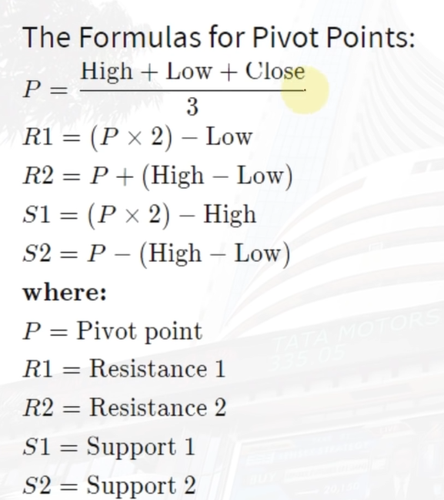

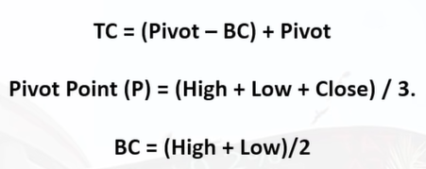

## Wide range cpr:

If the range between TCP and BCP is wide, then it is called wide range CPR, if the **previous day is trending (either bullish or bearish),** then thenext day will have **wide range CPR** and the price movement might mostly be **range bound**

## Narrow range CPR:

If the range between TCP and BCP is narrow, then it is called narrow range CPR, if the **previous day is very less volatile,** then thenext day will have **narrow range CPR** and that indicates the market is in **trending**

By default the **CPR range is not much effective**

## Deciding uptrend or downtrend with CPR:

If today’s CPR lines are closing above yesterdays CPR (**only pay attention to CPR range don’t include support and resistance levels**) and if it continues to do so, then it means the **Bullish trend**, vice a versa **bearish trend**

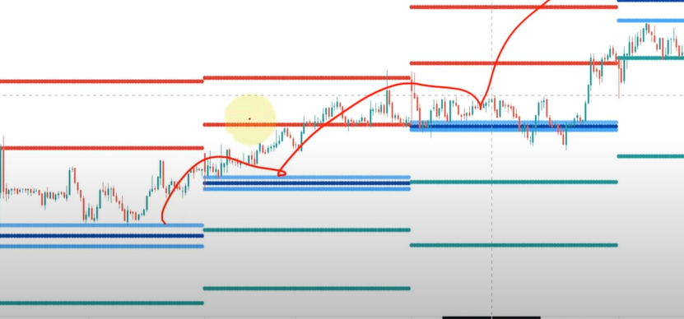

## Types of CPR strategies:

### if opening is inside CPR range:

don’t execute trade until it comes out of CPR range, if it goes above, you can execute bullish trade, if goes below, you can execute bearish trade

### if opening is above CPR range:

if resistance r1 is above previous day high

then wait until it sustains above previous day high, the gap between current price or Previous Day High (PDH) and R1 is **x points, then x points is target and x/2 points is stoploss, if it sustains above target, then keep the target as sl and keep next resistance R2 as target, as we are doing scalping, the time is low, so enormous price movement is possible in rare cases and most of the times price does not move much, so if the target 1 is met (sustains above R1) difference between r1 and r2 is 10% of stock price, then keep 3% or 5% or 7% as target and SL as R1**

if PDH is above R1:

then wait until it sustains above previous day high, the gap between current price or R1 and Previous Day High (PDH) is **x points, then x points is target and x/2 points is stoploss, if it sustains above target, then keep the target as sl and keep next resistance R2 as target, as we are doing scalping, the time is low, so enormous price movement is possible in rare cases and most of the times price does not move much, so if the target 1 is met (sustains above** PDH**) difference between PDH and r2 is 10% of stock price, then keep 3% or 5% or 7% as target and SL as PDH**

**CPR is not having a typical rulebook. Read above 2 scenarios, and then develop psychology and try applying logic based on the psychology you attain from it**

# ATR and Parabolic SAR:

Video link: <https://youtu.be/JzJVaHbLjHI>

Suppose you took a trade and it is running in your favour and it is in profit and has not reached target yet, this indicator will help you understand key pivot price point where

1. the trade might take reversal to enter or exit a particular trade
2. Also this indicator might help you trail SL

## Parabolic SAR:

**Works only for trending markets(uptrend or downtrend).**

If you just type in SAR in indicator and click on the Parabolic SAR, then the indicator gets applied and it will show dots on the chart, if the dots are above the cmp, then are chances that the price is gonna fall, if the dots are below the line, there are chances that price is gonna go up

Important points to note in parabolic SAR:

1. The more the gap between the dots and the price, more the chance of the ongoing trend(bullish or bearish) to continue
2. When the dot is nearing the price, chance of reversal become higher

## ATR (AVERAGE TRUE RANGE):

When we take a trade and want to place SL a few points below to the important support level, we might face a scenario where the price just comes till or a few points below SL and again rallies, so to decide the points at which we should be keeping SL we can use ATR.

To apply this indicator, you just type in ATR or “Average True Range” in indicator and click on it, then the indicator gets applied

Important points to note in ATR:

1. ATR value increases highly with timeframe, if it is 2 for 5 min timeframe, it has the possibility to be around 30 for daily time frame which is around 15 times, so it is important to see time frames and decide SL at lower timeframe (see time frames here)
2. ATR will be high for volatile stocks (or stocks with very large candles) compared to NON volatile stocks (or stocks with very small candles)
3. ATR will help us fix target and SL when we take blind trade, trades which we take based on news or something, if ATR at the cmp(or at the price where we took the trade) is X, then we can give SL as X and target as 2X or SL as X and Target as X, based on other factors, confluence and conviction

## Intraday strategy with CPR, ATR, PRICE ACTION:

* Video link: <https://youtu.be/hVxzA8_LRR4>
* **Time frame for this particular strategy: 5 min (in general for intraday we use 15 min strategy)**
* Works mostly with **volatile stocks**
* Capital required:1 lakh
* Indicator already made in my fyers with name: cpr,atr,price action intraday

### Back test details with

* + Nifty : 12.9%
    - 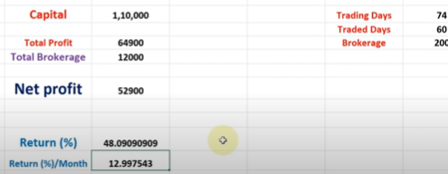
  + Bank nifty:
    - 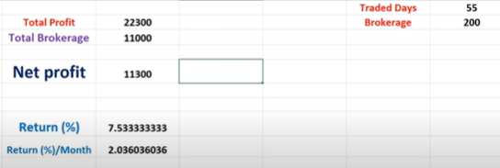
  + Bajaj finance:
    - 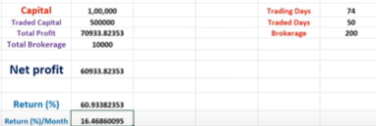
  + Tata steel:
    - 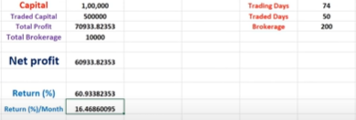

### Setup in this strategy:

More detailed explanation about this here



### Rules in this trade:

* We don’t enter if scrip opens below support s2 or above resistance r2 (a gap up or gap down might be the reason for this)
* We will take bullish trade only when price crosses (and candle closes) the first line that comes above TCP (might be R1 or PDH) or bearish trade if the price goes below (and candle closes) the BCP(might be S1 or PDL).
* Reversal trade for sell: if the scrip opens gap up and if it starts falling if it breaks r2, then we can take sell trade, else if it breaks the immediate line after R2 i.e., (PDH or R1), then also we can take sell trade, totally we take any of the 3 trades based on the scenario, when it breaks R2, R1, PDH. Target will be TCP

* + 
* Reversal trade for Buy: if the scrip opens gap down and if it starts moving, up then if it breaks S2, then we can take buy entry, if it breaks S2, then we can take buy entry, also if it breaks the immediate line after S2 (can be PDL or S1), then also we can take buy entry. We can take any of the 3 trades when it crosses S2, S1 or PDL, target will be BCP

* + 

### Target and SL:

Each of the time, when it crosses the line (more detailed explanation here: <https://youtu.be/hVxzA8_LRR4?list=PL_Bj8MwxMrhpVCGjA2wuMjAntQ1lmQYKF&t=1463> ) we want it to cross, then we will take trade in next candle opening. Place the cursor on the candle where it closed the line, SL should be the ATR (indicator) value (SL should be calculated from the line it crossed not the candle closing position)+gap between next candle opening and the crossed line, Target should be twice of SL.

Detailed explanation of SL value: here- <https://youtu.be/hVxzA8_LRR4?list=PL_Bj8MwxMrhpVCGjA2wuMjAntQ1lmQYKF&t=1579>

Another way of keeping SL and target

<https://youtu.be/hVxzA8_LRR4?list=PL_Bj8MwxMrhpVCGjA2wuMjAntQ1lmQYKF&t=1690>

# VWAP:

When we combine price levels and volume before we take a buy/sell call, we get comparatively better results.

VWAP: Volume weighted Average Price, this index will help you to generate buy/sell signals by combining volume and price of the scrip

**VWAP** is widely **useful in intraday** trading, there is an extension to VWAP, which is **Anchored VWAP** which is useful in generating suggestions which are **helpful in Swing trade and Investment**

**Values of VWAP does not change like MA does, values of VWAP remain constant for different time frames as VWAP is calculated per day (day starting to day ending)**

## Points to consider in VWAP:

If price falls below VWAP, then we consider it as bearish

If the price is above VWAP and the direction of VWAP is flat, like red line in the below image, if the line is above the price and if it is moving up, then more chances of bullish confirmation, and vice a versa for bearish confirmation

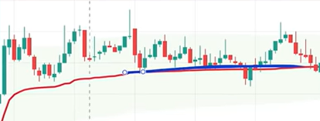

In 5 minute chart you can see sudden spurt when the day changes, ex: June 28 to June 29 of idfcfirst chart in 2022

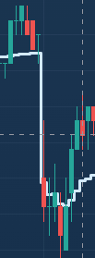

## VWAP calculation:

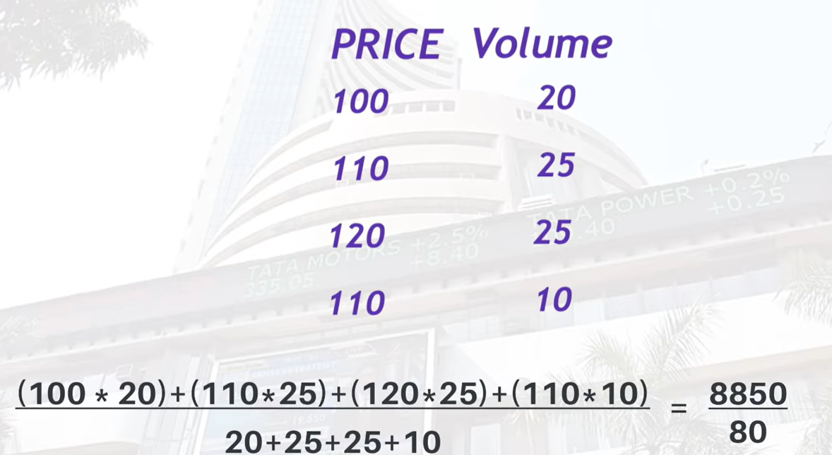

## Intraday strategy using VWAP:

Time frame: 15 min tf for trend confirmation, 5 min tf for trade execution

Exponential Moving average: 50 days

Indicator name in fyers with timeframes: VWAP EMA for intraday trade

Does not work on **indexes** as we don’t have volume in indexes

See the previous trend in 15 min timeframe first

Don’t do trades in the first 30 minutes of market opening

**Mean reversion Theory:**

Even after heavily moving upside/downside the stock price tries to have a pull back to come closer towards its mean price, when we try to trade with any indicators If the price moves heavily one directional and if the price is way above the VWAP, avoid trading till the price comes near to the VWAP line. In the below image taking trade at 2% higher to the VWAP might result in loss because we might not know if that is a pullback or reversal. This approach not only holds good for VWAP but for any indicator

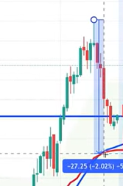

If the trend is bullish, we will take buy call when the price moves above both 50 day ema and VWAP, in the below image look at the blue circle, it will just help in increasing the probability of avoiding frequent hitting of SL.

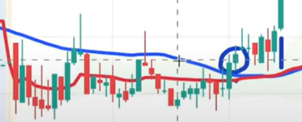

For further confirmation, you can use RSI (preferred over MACD) or MACD

Else price action (like support and resistance (preferred over trend) or trend) is another best option to increase confluence

SL can be fixed using ATR (for more details on SL using ATR here) or recent candle low

## Anchored VWAP for Swing or investment related:

Timeframe : 1hr for trend confir

In down trend when you are seeing a pullback and a lower high is formed then click on that point after selecting Anchored VWAP like the red circle in the below image

Difference between VWAP and Anchored VWAP is that VWAP calculates from the starting of the date and Anchored VWAP will start calculating VWAP from the click of a point

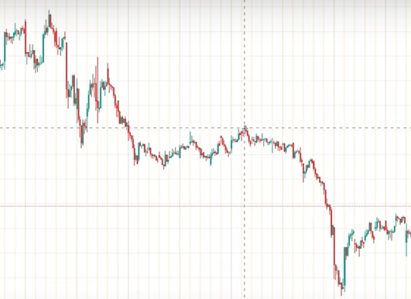

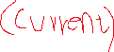

### 2 important points in Anchored VWAP:

It is better to look the video from below point till end

https://youtu.be/TRe7Qon84TI?t=1159

In down trend we select swing high (lower high) to click to start calculating VWAP from that point in Anchored VWAP setting set **source parameter** as **high (byheart swing high so select high)**

In up trend we select Swing low (higher low) to click to start calculating VWAP from that point in Anchored VWAP setting set **source parameter** as **low (byheart swing low, so select low)**

Entry and exit should be based on trend or Fibonacci or some other indicator, Anchored VWAP will show the value zone where we can add furthermore qty there

### SL:

As we are taking decisions with trend, it is best to keep previous Higher low as SL in bullish trend and Previous Lower high as SL in bearish trend

### Note:

This strategy holds good for bonuses, splits, positive news, negative news will let us know value zones from that particular points where the event starts

# SL in general:

SL must be calculated as ATR value at trade point + recent high for bullish trade and

Recent low – ATR at trade point for bearish trade

# MACD:

Link: <https://youtu.be/ixX0NX4z2N0>

Timeframe: most possibly 15 min

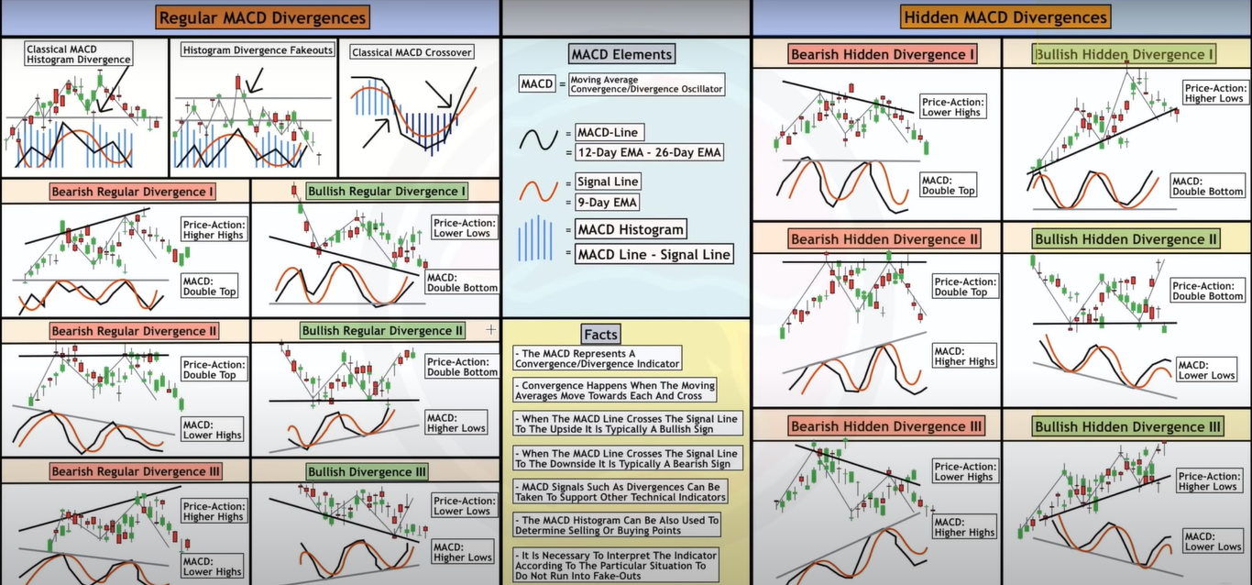

When you search for MACD in indicators and apply trading view chart setup, if you go to the settings of MACD, then you can see the below image, MACD and signal stand for MACD line and signal line

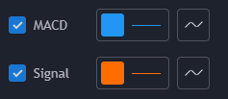

## Calculation behind MACD:

MACD line = 26EMA – 12 EMA

Signal line = sum of past MACD line

Histogram value at a particular point = MACD line value at a particular point – Signal line at a particular point

## Theoretical understanding:

Bullish crossover- MACD line crossing Signal line

Bearish crossover- Signal line crossing MACD line

**It should be seen in higher timeframes (with timeframes starting from 1 day) to avoid fake breakouts**

## Histogram components and their possible values in confluence point of view:

The color may give slightest of signals, but the below **pattern** component gives a bit more further understanding

* Color
  + Red bar – negative
    - Thick Large red bar: negative view (probably a sign of bearish view)
    - dull large redbar: positive view (maybe a positive sign for bullish reveral)
    - dull Small red bar: neutral to positive view (probably a sign of neutral to bullish reversal)
    - thick small red bar: neutral to negative view (probably a sign of start to bearish trend)
  + Green bar – positive
    - Thick Large green bar: positive view (probably a sign of bullish view)
    - Dull large green bar: negative view (probably a sign of bearish reversal)
    - thick small green bar: neutral to positive view (probably a sign of neutral to bullish trend starting)
    - dull small green bar: neutral to negative view (probably a sign of bearish trend)
* pattern:
  + green ascending : bullish
  + green descending: bearish reversal
  + red ascending: bearish
  + red descending: bearish reversal

## how to include MACD for confluence trade?

Link: <https://youtu.be/ixX0NX4z2N0&t=13m>

1. To get more idea when a bullish or bearish candle is forming near support/resistance with bullish or bearish crossover with MACD
2. Checking the histogram (ascending/descending formation as discussed above) formation near support/resistance with price action at corresponding levels
3. When the bars in MACD histogram are thin (dull) then waiting for the scrip to cross the recent high level (a horizontal trend line) will be a good approach

## Divergence:

### What is divergence

A move is called divergence, when the price is moving in one direction and the indicator is moving in the opposite direction or staying neutral



### Why Divergence with MACD:

This combination increases the confluence, **when you are in a bullish/bearish trend, Divergence with MACD will give you early indicators for a potential reversal of trend**

### Types of divergence

#### Regular divergence

Easy to identify

* Bullish regular divergence: if the scrip is in a bearish trend and the price is moving down and the indicator is staying neutral or moving in upside, then there is a chance that the bearish trend is going to break and bullish trend is going to start and that is called **bullish regular divergence**
* Bearish regular divergence: if the scrip is in bullish trend and at a point, if the price is moving up and the indicator is staying neutral or moving downside, there are good chances that the current bullish trend is going to break and a bearish trend might start, this is called **bearish regular divergence**

#### Hidden divergence

Bit complicated to identify

The divergence which is forming by supporting the trend (bullish or bearish) and further indicating an possible move in the same direction is called **hidden divergence.**

### How to observe

Timeframe: 15 min

#### Formation of Bearish Regular divergence I:

Price is moving up but the MACD stays at same level

#### Formation of Bullish Regular Divergence I:

Price is moving down, but the MACD stays at same level

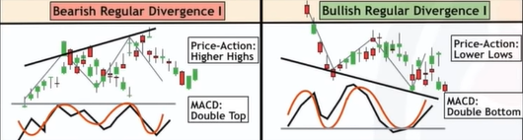

#### Formation of Bearish Regular divergence II:

when the scrip is in a bullish trend and price is at a level X and MACD(blue line value) at that point is 10 and after some days also the price is at level X, the MACD level at 5, then we can confirm bearish divergence II as shown in above figure

#### Formation of Bullish Regular divergence II:

When the scrip is in a bearish trend and price is at level X and MACD value is at point 10, and if the price comes to same level X after few days, then MACD level is at 15, then we can confirm Bullish divergence II as shown in below figure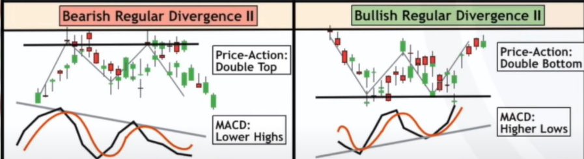

#### Formation of Bearish Regular divergence III:

The price is moving upside but the MACD level is moving down

#### Formation of Bullish Regular Divergence III:

The price is moving down but the MACD level is moving up 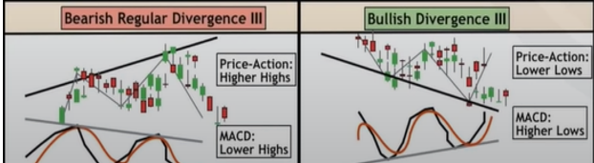

### How to trade:

When you are seeing any Divergence (Bearish Regular divergence II or bullish Regular divergence II), you can closely watch the scrip and you can see the recently formed low (high for bearish trend) in a bullish trend to wait till it **closes below** (above for) that line and then take a trade, if you don’t want to look at highs and lows then look at 9 day EMA, look for the scrip to **close above** 9 day EMA for Bullish Regular divergence II, look at 9 day EMA to close below for Bearish Regular divergence II

**Prima facie 9 day EMA looks best for entry**

##### SL can be kept using

* ATR value + recent high for Bearish regular divergence
* ATR value + recent low for Bullish regular divergence

##### Target:

If the SL is x keep the target as 2x or 3x to have a risk reward ratio of 1:2 or 1:3

# RSI trading strategy (powerful intraday trading and swing trading strategy)

Link: https://youtu.be/4oa5zeOzBl0?list=PL_Bj8MwxMrhpVCGjA2wuMjAntQ1lmQYKF&t=247

RSI- Relative Strength Index : a momentum indicator used in technical analysis that measures the magnitude of recent price changes to evaluate **overbought or oversold conditions** in the price of a stock or other asset

## How to apply on chart

1. Select indicators and search for RSI or Relative Strength Index
2. Click on it, RSI by default uses length 14
3. You can see a partition of something like this below image

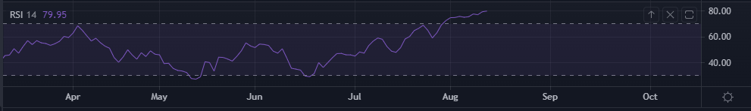

## How to not use RSI

If a scrip is overbought (RSI above 70) that is not the indication that you should sell, **overbought simply means the scrip is bought more than it usually is**. There is **equal probability for 2 things**

1. To sustain there and move upwards
2. To have a reversal

## How to look at RSI

On the above image you can observe numbers at the left and you can also see the highlighted partition of 30 to 70 if the line is above 70, it might be an indication for overbought and is possibly in bullish trend, and similarly line below 30 might be an indication for oversold and might be in bearish trend. If the RSI is above 50, then it is indication of bullish momentum, that means the last 14 (RSI Length, 10 is preferred for people who need quick signal, decrease in RSI length will increase sensitive count of overbought and oversold levels) candidates indicate that the bullish move is in place

* In over bought zone: be cautious and don’t take buy positions unless for a strong motive (like sustaining above important level or confirmation of higher high or breaking day’s high or forming strong candles), and have a bias towards bearishness if the rsi levels starts falling below 70, **we can take sell action if the RSI level starts falling below 70 and price action supports the move**

We will think the scrip is in a positive move, if rsi is moving up between 30 and 70

When a scrip is in bullish trend, there are 4 possibilities

1. To have a small pullback and again form higher highs
2. To go into bearish trend
3. To remain sideways and then move bearish or bullish again
4. To continue in bullish trend

### RSI helps in noticing points 1 and 2

#### Identifying a bearish trend

When the rsi value is already above 70 and if it moving below 70, then we can look for bearish trend

## Combing RSI with price action and developing a high probability trading strategy

We need understanding of bullish and bearish divergence to trade with RSI, to get a better understanding of divergence, read MACD strategy here

### Trading with bullish divergence using RSI

As it is for trading we will have time frame of 15 min

#### Step 1

1. Check for bullish divergence in bearish trend or bearish divergence in bullish trend
2. Increase confluence by checking if it is in **overbought zone in bullish trend, check for its support level** or **oversold zone in bearish trend, check for its resistance zone**

As discussed above in MACD strategy about divergences, a bullish divergence is formed in a bearish trend, check for divergence where the RSI is moving up and the price is moving down, as similar to below image

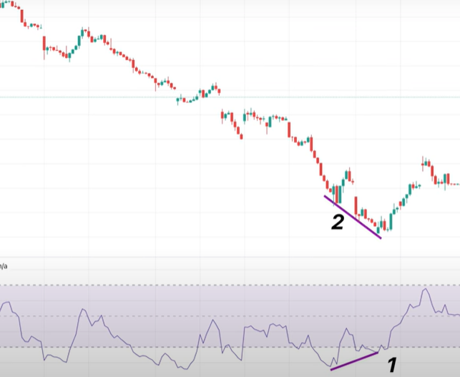

#### Step 2

##### Timeframe

###### 2.1 Swing trading

Change timeframe to 1 hr, try finding divergence

Used if we find divergence in 1 hr timeframe

Take trade and fix target and SL after changing graph to 15 min timeframe

Might need to carry for few days

###### 2.2 intraday

find divergence in Higher timeframe for 15 min

Take trade and fix target and SL after changing graph to 5 min timeframe

#### Step 3

If possible try to include price action here and check for major levels of support and resistance and also include bullish/bearish reversal formations or candle formations

#### Step 4

Apply 49 EMA

Take an entry when the price crosses and closes above 49 ema after the bullish divergence, keep the SL as recent swing low or the ATR value (if the swing low is too far, then you can use ATR, if the ATR is too high, vice a versa), TARGET as the recent swing high

# 1 hour candle breakout strategy

Link: <https://youtu.be/49VyiKUlKmg>

Backtesting information of this strategy is successful for nifty, bank nifty and reliance with around 70% probability

This strategy holds good for nifty, bank nifty, and reliance, we can backtest for other nifty 50 or nifty 100 stocks and check if it work for other scrips

Template details:

* Add RSI and ADX in chart
* RSI Length: 10, range: 40-oversold, 60-overbought
* ADX: ADX smoothing: 10
* Draw a horizontal line at 30 in ADX

Template made in fyers: rsi,adx, 1 hr candle breakout strategy

## Step 1: selecting 1 hr candle using RSI and ADX

To select a hourly candle it should be satisfying below conditions

1. ADX >30
2. RSI < 40 or RSI >60

## Step2: entry and stoploss

In hourly timeframe, when you find a candle satisfying above conditions, that candle is called **reference candle,** concentrate on the body of the **reference candle the bottom and top of the candle is considered**.

### When to buy and when to sell:

**Buy :**

**when the next candle moves up the top (not the wick high) of the reference candle, SL will be the the bottom of the reference candle**

**Sell:**

**When the next candle moves below the bottom (not the wick low) of the reference candle, SL will be the top of the reference candle**

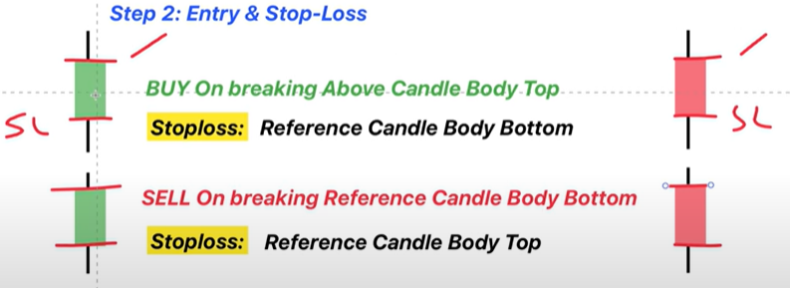

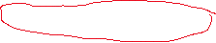

### Entry

More detail here: https://youtu.be/49VyiKUlKmg?list=PL_Bj8MwxMrhpVCGjA2wuMjAntQ1lmQYKF&t=329

Draw horizontal lines at reference candle top and bottom, move top line up by X points and move bottom line down by X points

X points for nifty is 10 points

X points for Banknifty is 20 points

Moving line by 10 or 20 points is called spread. This is useful in avoiding backfiring or reversal

#### If next candle is moving above the reference candle i.e., BUY

SL is the bottom of the reference candle or the below spread line used above

#### If next candle is moving below the reference candle i.e., SELL

SL is the up of the reference candle or the below spread line used

## Step 3: Target

If stop loss is X then min target should be X or 1.25 * X. i.e., if SL is 50, then target should be 50 or 62.5. if the candle is too low, then trail stop loss till you get a risk reward ratio to 1:5

## What to avoid while using this strategy

1. When you are at first hour candle (9:15 am candle) or last hour candle (3:15 pm candle) to avoid volatality
2. When SL is > 0.5% of scrip price
   1. Ex1: if nifty is trading at 17000 then 0.5 % of 17000 is 85 if sl is greater than 85, we will avoid the trade
   2. Ex2: if banknifty is trading at 36000, then 0.5% is 185 if sl is greater than 185 we will avoid the trade.

# ADX

Average Directional Index (directly available as indicator in trading view), is a lagging indicator

Helps in analyzing Strength of existing trend

It helps in identifying strength in movement (either up or down) of the scrip

If the ADX is moving up, then it means the movement in price (either up or down is happening with strength)

|  |  |  |
| --- | --- | --- |
|  | adx moving up | adx moving down |
| price moving up | strength in upward move | no strength in upward move |
| price moving down | strength in upward move | no strength in upward move |

9EMA,21EMA,ADX, 1 hr Timeframe

The ADX can be used to increase confluence, and also avoid false cross overs of EMA, because in rangebound you can have bullish and bearish cross overs, you can avoid them if you analyse previous ADX levels over which the scrip has given breakouts(draw horizontal line probably maybe around 25 or 30 levels not perfect level, but gives a headsup, we can observe and set levels accordingly ) from rangebound movements and set scrip particular ADX levels

## Levels:

0 to 20 : rangebound

20 to 30 : transition (be alert and analyse price action)

30 to 60 : Directional move (best)

Greater than 60 : very strong -> avoid

# Bollinger bands + RSI

Link: <https://youtu.be/UaXkKgqy1CE>

Search for Bollinger Bands on trading view chart and apply

An area with 3 lines is applied and the middle line is applied default length,

Default length in settings is 20SMA which is past 20 candles 20 Simple moving average

The upper and below lines are standard deviation

If the middle line (20 SMA) is mean, then upper line is mean + 2* standard deviation, lower line is mean – 2* standard deviation

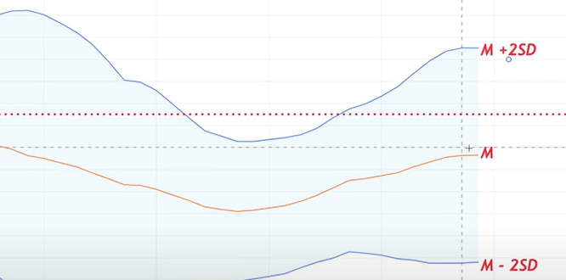

## Understanding the trend using Bollinger bands

In moving averages we assume the trend as bullish if the price movement is above the moving average line and we assume the trend as bearish if the price movement is below the moving average line

Similarly if the price is above the mean (the middle line) then the scrip is considered as bullish, if the price is below the mean (the middle line) then the scrip is considered as bearish

## Understanding volatility using Bollinger bands

If the range of upper line and lower line is increasing, that means the standard deviation is increasing in the past 20 days, that means the (up and down) movement from the mean is high, which indicates the volatility is high

## Support and resistance using Bollinger bands

Bollinger bands help in identifying the support and resistance **probable zones** , because the support and resistance cannot be merely identified by just looking at standard deviation values of past 20 days price movements

The scrip has a chance of taking support when the price reaches the lower standard deviation line

Similarly it has a chance of facing resistance when the price reaches the upper standard deviation line

## When is bollinger bands useful

1. To develop confluence for support and resistance and also to develop confluence for trend
2. To build position, ie, you know the probable support and resistance zones, therefore if you had took a trade and if you want to add further positions at support or resistance levels, it helps
   1. If you are in a bullish trade, then it is ideal to build further position when at the next higher low, i.e., when the price takes retraces down and reaches the mean line (middle line) 20 sma line
   2. If you are in bearish trade, it is better to build further position at the next lower high, i.e., when the price retraces up and reaches the mean line

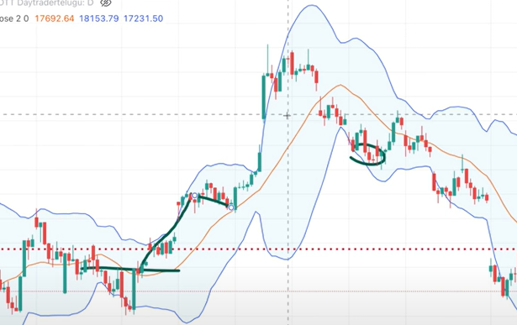

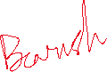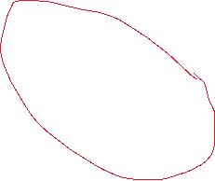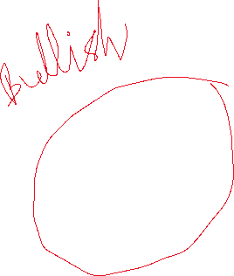

## Strategy using Bollinger band: out-inside bullish

Time frame:

15 min for swing trade

5 min for intraday (pattern formation for this time frame is more when compared to 15 min timeframe)

Fyers template: Bollinger, RSI, ATR

### 1:Double bottom (for bearish trade we will look at double top)

W shape by scrip

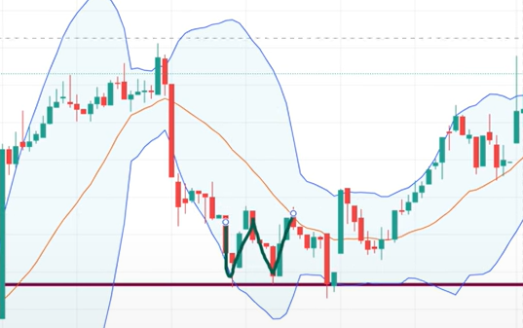

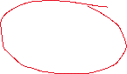

### 2: volatility divergence

If the scrip price range comes out of Bollinger range (upper line and lower line), then we can treat it as volatile. That is volatility divergence

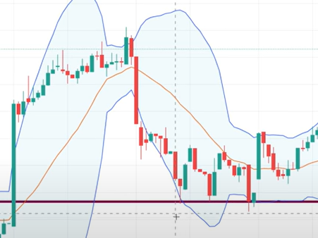

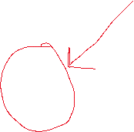

Volatility divergence: you can see that at P1 the candle is touching the Bollinger band lower line, but after that at P2 price is at same level, but it is not touching Bollinger band.  **There is a divergence.**

### 3:confirmation

Formation of green candle in bullish trade (red candle in bearish trade) acts as confirmation

### 4:RSI divergence

Importance of RSI divergence: it is not possible every time to form a double bottom, at that time you can not use the step 2- **volatility divergence** so in those cases we can go for different types of RSI divergences already discussed in RSI indicator section here

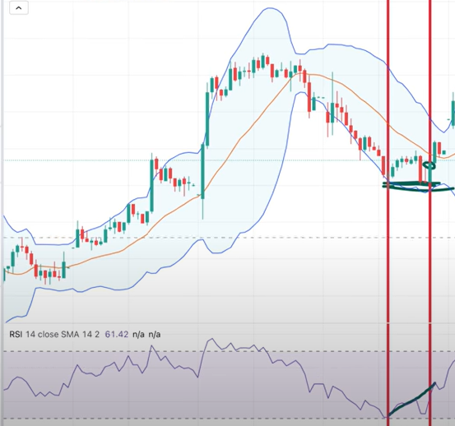



When you check for RSI divergence, you can see that RSI levels at point 2 are higher than RSI levels at point 1. Which indicates a bullish reversal, This increases **confluence**

### SL and target and entry

Sl will be ATR value (at candle formation in step 3) + the bottom line formed in Double bottom shape above

Target should be 1.5 * (entry – Stop loss)

We will take entry at the green candle formation on P2

### Examples to avoid

In the below image the conformation candle of bearish trade is too long, which indicates that SL might be too large, so it is better to avoid such trades

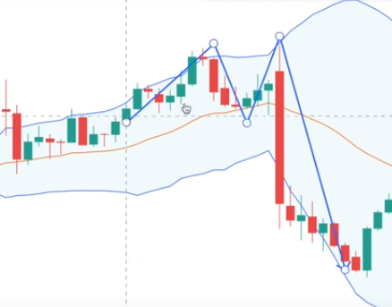

### Steps to follow

Add 3,4 stocks to watch list

Paper trade for at least one month

# Strategies:

## Intraday Strategies:

* Fibonacci intraday and swing strategy: here
  + Indicator name in my fyers: name: cpr with 5 min timeframe for scalping or to enter to a scrip when it breaks trend
* Intraday strategy with CPR, ATR, PRICE ACTION: here
  + Indicator name in fyers: name: cpr,atr,price action intraday
* Intraday strategy using VWAP
* 1 hour candle breakout strategy (this can be used for option trading and normal scrips as well): here

## For long term

* CPR strategy to try to enter to a stock in a day (for long term) : here
* Strategies : here
* Swing or long term trade using anchored VWAP here

## Other Strategies:

* Atr and parabolic sar, to develop confluence while looking at trend reversal here

## Strategies when waiting for bullish reversal:

* MACD strategy (which uses divergence) : here
* RSI Strategy (which uses divergence as well) : here

## Option trading allowed strategies

* 1 hour candle breakout strategy (this can be used for option trading and normal scrips as well): here

## Rangebound breakout related

* To develop confluence when the scrip is in rangebound or going to break rangebound: here

# Rules for technical analysis:

1. Identify the trend and try to take trade in the direction of trend, i.e., bullish trend means we have to go with buy signals
2. A

# Points to note to develop Psychology:

1. Almost 100% sure that there is no strategy which will give you 100% accuracy, there will be losses in every strategy, understand **losses are internal part of the strategy**
2. Successful people are not who know a lot of things, but who know how to follow disciplined risk-reward ratio
3. If you are getting consecutive losses for 5 or more days while applying a strategy, then try to understand the market conditions (better to trade with less quantity or not to take trades in such a days)
4. If you are not able to afford to lose money, while looking at risk reward (based on the rules you are following) don’t try to bring up the stoploss (so that it will let you think, in case if the trade goes in opposite direction, you will lose less money), instead reduce the quantity you trade

# misc:



* Divergences included indicators provided best risk reward

# Checklist

* Check the trend and draw trend lines
* Check recent volumes in volume pane
* Check for divergences in MACD
* Check for CPR to understand daily levels
* Check for RSI to see oversold or overbought or normal